Group Project Documentation   
C# Programming and Unity

*<Hero Knight>*

**Prepared by <3>**

1. ***<Nguyễn Võ Tùng Lâm>***
2. ***<Hoàng Chí Dương>***
3. ***<Lê Long Nhật>***
4. ***<Lê Đình Thành>***

Ho Chi Minh City, 2024

**Table of Contents**

**1.****Game Introduction 1**

**2.****How to play 1**

**3.****Game Design Specification 1**

**4.****Project Management 2**

**5.****Implementation 2**

5.1. Deployment Considerations 2

5.2. Screenshots and explanations 2

**6.****References 2**

**Revision History**

|  |  |  |
| --- | --- | --- |
| **Name** | **Date** | **Reason For Changes** |
| Nguyễn Võ Tùng Lâm | 31/1/2024 | Create scene lv 1 |
| Lê Long Nhật | 31/1/2024 | Create scene menu |
| Lê Đình Thành | 31/1/2024 | Create scene lv 2 |
| Hoàng Chí Dương | 31/1/2024 | Create scene game over |
| Nguyễn Võ Tùng Lâm | 22/2/2024 | Hero move, jump, fall |
| Nguyễn Võ Tùng Lâm | 24/2/2024 | Fix move, jump, add camera controller, |
| Nguyễn Võ Tùng Lâm | 27/2/2024 | Enemy controller, detection zone |
| Nguyễn Võ Tùng Lâm | 2/3/2024 | Health bar hero , sound effect, health pickup |
| Nguyễn Võ Tùng Lâm | 4/3/2024 | Fix health bar |
| Lê Đình Thành | 24/2/2024 | Design scene lv2, boss animation |
| Lê Đình Thành | 29/2/2024 | Damage boss, health bar boss |
| Lê Đình Thành | 3/3/2024 | Fix health bar boss, script load scene over game and victory |
| Lê Đình Thành | 7/3/2024 | Update scene lv 2 |
| Hoàng Chí Dương | 3/3/2024 | Add script control scene. |
| Hoàng Chí Dương | 5/3/2024 | ReDesign scene Victory and gameover. |
| Hoàng Chí Dương | 6/3/2024 | Update scene game over and victory |
| Lê Long Nhật | 1/3/2024 | Add script control scene. |
| Lê Long Nhật | 4/3/2024 | Add scene description |
| Lê Long Nhật | 7/3/2024 | Update scene menu, description |

# Game Introduction

# Welcome brave knights to our magical world of adventure! In this game, you will go through a challenging journey where your talent and courage will be put to the ultimate test. You will have to overcome unexpected encounters and fight evil enemies, from dangerous monsters to knights dominated by darkness. And at the end of the journey, you will directly face the king of dark monsters, the person behind all incidents and dangers. Only by defeating this monster king will you have a chance to bring peace to this world. Prepare yourself and start your journey now!

# How to Play

* Character control:
* Move left/right with A/D.
* Jump using Space.
* Run fast with Shift.
* Attack with left mouse button (3 consecutive attacks).
* Item system: Potion heals when touched by character.
* Enemy:
* Act 1:
* The blackened knight moves and attacks automatically.
* One-eyed flying monster moves and attacks automatically in the air.
* Act 2:
* Big monster
* Game screen:
* Menu screen: Start, exit, instructions.
* Stage 1: Adventure stage, fighting small monsters
* Stage 2: Boss battle stage
* The scene ends.
* End conditions:
* The character loses all his health (loses).
* The character defeats the boss (wins).

# Game Design Specification

**Character control:**

* **Move:**
  + Use the A button to move left and Use the D button to move right.
  + Hold down the left Shift button to move faster.
* **Jump:** Press the Space key to jump the character.
* **Attack:**
  + Left-click to attack character.
  + The attack animation has 3 turns:
    - Turn 1: damage 10.
    - Turn 2: damage 10.
    - Turn 3: damage 20

.

**Items: Potion**

* + When the character loses blood, touch the potion to heal 10 health for the character.
  + The potion will disappear after being used.
  + The character cannot interact with the potion when the health is full (100/100).

**Scene:** 6

**1. Menu scene:** There are 3 buttons for players:

* + Start: Open scene level 1.
  + Quit: Close the app.
  + How to play: Open scene How to play

**2. Screen Level 1:**

* 2 type of enemy:
  + **The Dark Knight:** 
    - Move and auto-attack.
    - Blood: 100.
    - Damage per hit: 10.
  + **Flying 1-Eyed Monster:**
    - Move and automatically attack in the air.
    - Blood: 50.
    - Damage per hit: 20.
* The map has 2 parts:
  + On the ground.
  + In the ground.

**3. Scene level 2:**

* Boss:
  + Health: 200.
  + Damage per hit: 25.

**4. Scene How to play:**

* Button Back: Go back to scene Menu
* Text: Mechanical guides for players to understand how the game works .

**5. Scene Game Over:**

* Button Play Again: Go back to scene level 1
* Button Main Menu: Go back to scene Menu
* Button Quit: Close the app.

**6. Scene Victory:**

* Button Main Menu: Go back to scene Menu
* Button Quit: Close the app.

**Note:**

* The character loses blood when attacked by monsters.
* The character's initial health at the beginning of the game is 100.
* Players need to use move, attack and dodge skills to win.
* Effect **:**
  + There is a blue bar in the upper left corner of the screen that will be the character's health bar
  + When the character passes the 2nd level (boss battle), there will be a red bar in the upper right corner that is the boss's health bar. When taking damage from a character, the monster's health bar will decrease.
  + When hit by a monster, the character will lose health and the character's health bar will decrease and the character will see the amount of damage the monster causes to the character.
  + When hit by a character, all monsters will lose health and the amount of damage the character causes to the monster will appear.
* **Plot:** The monster lord is invading the human world, players will transform into a knight who is on a journey to destroy the monster lord to bring peace to the world.
* **Sound :** The game will have a classic video game-style soundtrack (8bit). When characters and monsters take damage or die, there will be sound effects. When the character touches the healing item and is healed, there will be sound effects.

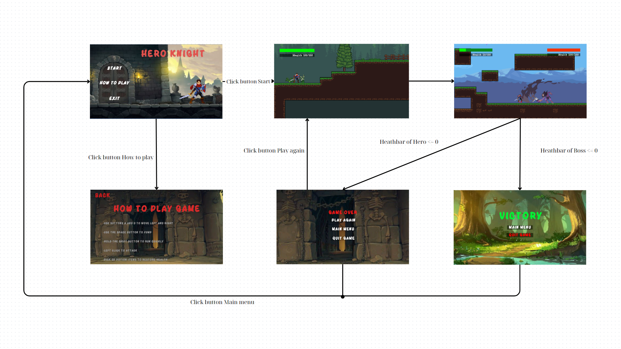

# Project Management

|  |  |  |  |
| --- | --- | --- | --- |
| **#** | **Task Name** | **Member** | **Note** |
| 1 | Scene Menu | Lê Long Nhật | Design scene, button, script script load scene |
| 2 | Scene level 1 | Nguyễn Võ Tùng Lâm | Design scene, Damage of hero, dark knight, flying eye, health pickup, load scene |
| 3 | Scene level 2 | Lê Đình Thành | Design scene, health bar of hero and boss, boss attack. |
| 4 | Scene GameOver | Hoàng Chí Dương | Design scene, button, script load scene |
| 5 | Scene Victory | Hoàng Chí Dương | Design scene, button, script script load scene |
| 6 | Scene Description | Lê Long Nhật | Design scene, button, script script load scene |
| 7 | Documentation | Lê Long Nhật,  Hoàng Chí Dương,  Lê Đình Thành  Nguyễn Võ Tùng Lâm | Lâm : Game Introduction, How to play  Nhật: Game Desgin specification  Thành: Implementation  Dương: Project manager  All team: References |

# Implementation

## Deployment Considerations

Information and Activities:

System Requirements:

Clearly define and communicate the minimum system requirements for playing the game.

Specify supported operating systems and hardware configurations.

Installation Instructions:

Provide detailed, step-by-step instructions for installing the game on various platforms (Windows, macOS, etc.).

Include information on any dependencies or prerequisites.

Testing:

Conduct thorough testing on different machines to identify and address compatibility issues.

Perform beta testing with a diverse group of users to gather feedback and address potential bugs.

User Training:

Develop training materials for end-users to familiarize them with the game controls and features.

Consider creating tutorial levels within the game to guide players on basic functionalities.

Documentation:

Prepare comprehensive documentation outlining the game's functionalities, troubleshooting tips, and frequently asked questions.

Include a README file with information on how to contact support for assistance.

Security Measures:

Implement necessary security measures to protect against potential threats or unauthorized access.

Provide information on how users can update their game securely.

## Screenshots and explanations

1. Screen Menu

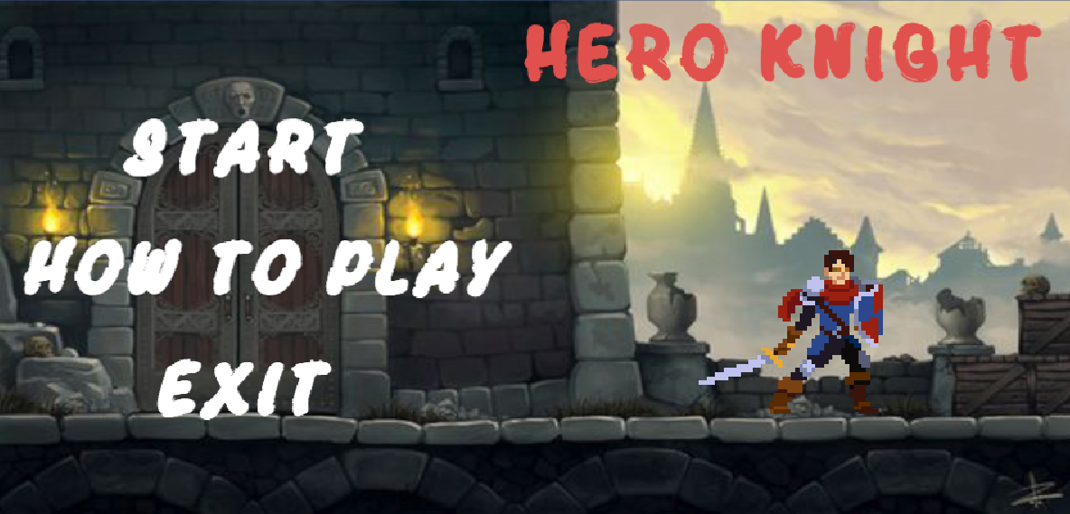

1 Game Name

Hero Knight

2 Button Start

-Press the start button to start playing the game

3 Buttons How To Play

-Click the How To Play button to go through the game instructions screen

4 Exit Buttons

-Press the Exit button to exit the game

2. Screen Description

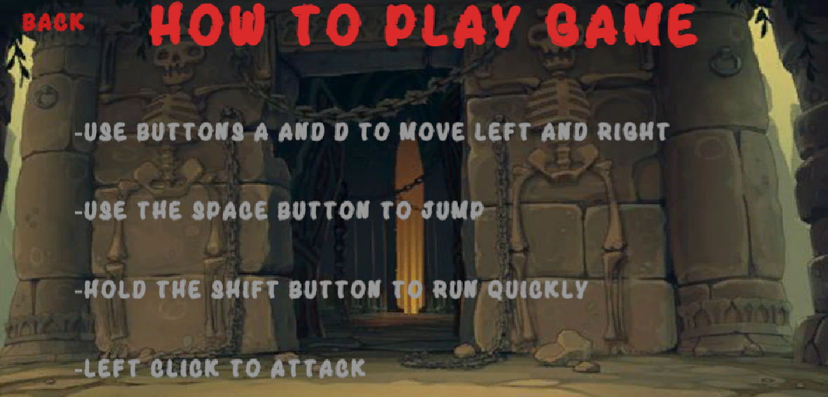

1 Title

2 Instructions

-Detailed descriptions of how to play the game

3 Button to return to Menu

-Press the Back button to return to the game menu

3. Screenlevel 1

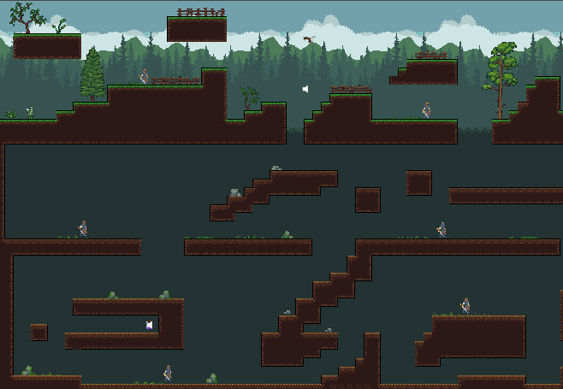

The map has 2 areas: ground and underground. When the character reaches the end, the underground area will have a gate so the character can go to the next level.

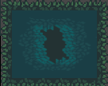The hero needs to go through the gate to reach the next level

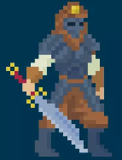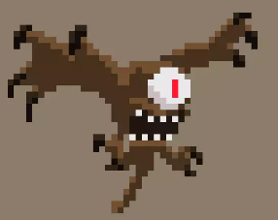There are 2 type of enemy in the map

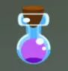 This is Item can recovery the health of hero.

4. Screenlevel 2

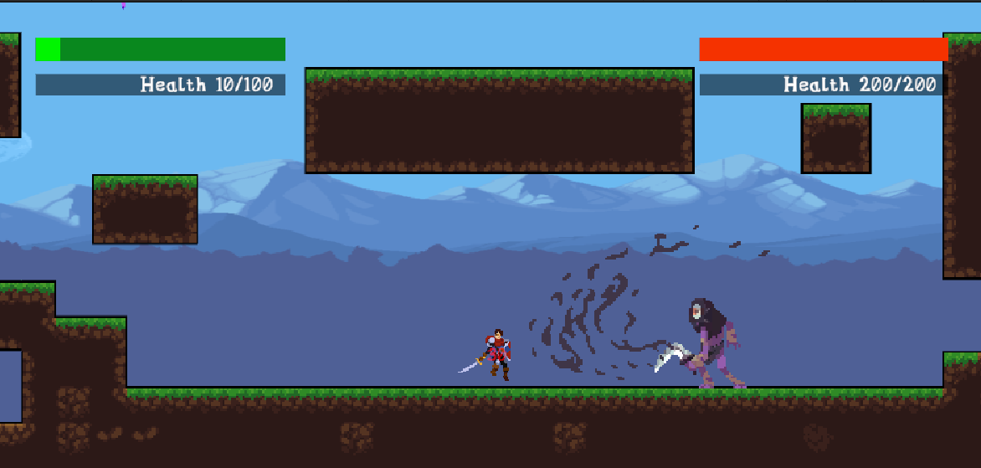

1. Boss Encounter

Description: The player enters the epic Boss Battle Stage, facing a colossal and menacing monster.

2. Boss Health Bar

Description: A health bar displayed at the top of the screen indicates the health status of the formidable boss. As the player inflicts damage, the bar decreases.

3. Player Victorious

Description: Congratulations screen appears as the player successfully defeats the colossal boss. The victorious moment is highlighted with celebratory visuals and a triumphant message.

5. ScreenVictory

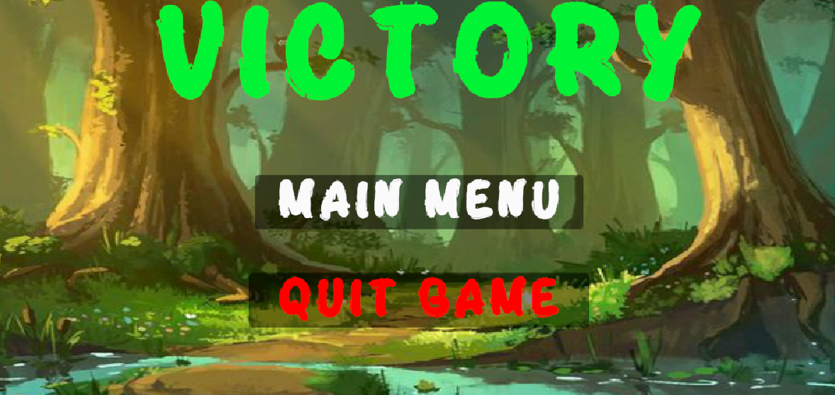

Press button Main Menu to go back to scene Menu

Press button Quit Game to close the application.

6. ScreenGame Over

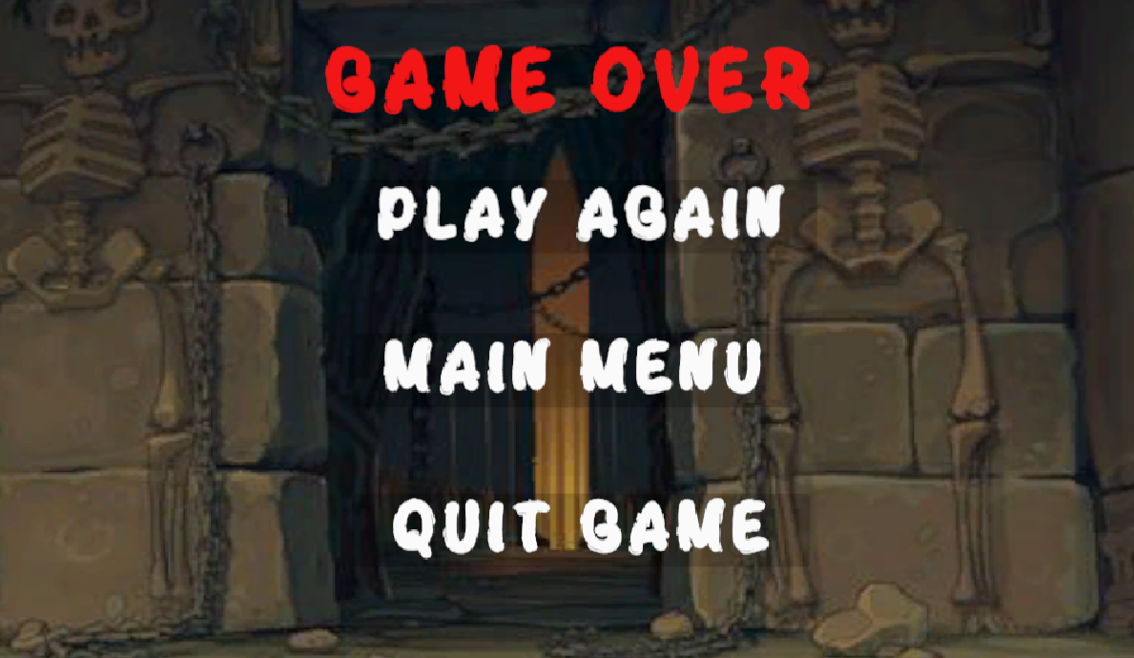

Press button Main Menu to go back to scene Menu

Press button Quit Game to close the application.

Press button Play Again to go to scene level 1.

# References

Asset Store:

[Bringer Of Death (free) | 2D Characters | Unity Asset Store](https://assetstore.unity.com/packages/2d/characters/bringer-of-death-free-195719)

[Voices Sfx | Voices Sound FX | Unity Asset Store](https://assetstore.unity.com/packages/audio/sound-fx/voices/voices-sfx-41754)

[Voices - Essentials | Voices Sound FX | Unity Asset Store](https://assetstore.unity.com/packages/audio/sound-fx/voices/voices-essentials-214441)

[SwordSoundPack | Weapons Sound FX | Unity Asset Store](https://assetstore.unity.com/packages/audio/sound-fx/weapons/swordsoundpack-177824)

[8Bit Music - 062022 | Audio Music | Unity Asset Store](https://assetstore.unity.com/packages/audio/music/8bit-music-062022-225623)

[Bubble Font (Free Version) | 2D Fonts | Unity Asset Store](https://assetstore.unity.com/packages/2d/fonts/bubble-font-free-version-24987)

[Monsters_Creatures_Fantasy | 2D Characters | Unity Asset Store](https://assetstore.unity.com/packages/2d/characters/monsters-creatures-fantasy-167949)

[Bandits - Pixel Art | 2D Characters | Unity Asset Store](https://assetstore.unity.com/packages/2d/characters/bandits-pixel-art-104130)

[Free Game Items | 2D Environments | Unity Asset Store](https://assetstore.unity.com/packages/2d/environments/free-game-items-131764)

[2D Pixel Art Platformer | Biome - American Forest | 2D Environments | Unity Asset Store](https://assetstore.unity.com/packages/2d/environments/2d-pixel-art-platformer-biome-american-forest-255694)

[Hero Knight - Pixel Art | 2D Characters | Unity Asset Store](https://assetstore.unity.com/packages/2d/characters/hero-knight-pixel-art-165188)